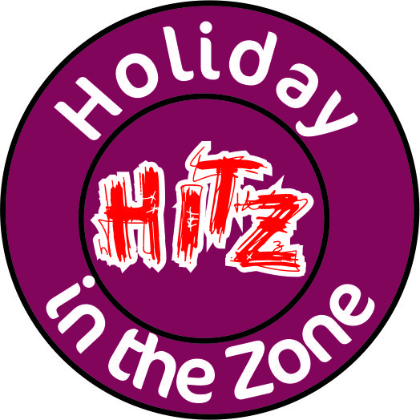
Carlisle Youth Zone
Victoria Place, Carlisle, Cumbria, CA1 1LR
info@carlisleyouthzone.org www.carlisleyouthzone.org 01228 516280
Application Form
Please complete all sections below – clearly and in CAPITAL letters
Please note that places are limited and will be allocated on a first come first served basis
You must pre-book and pre-pay by cash or cheque or card payable to ‘Carlisle Youth Zone’
Young Person Details:
CYZ Membership number: | If you do not have a current membership please complete a membership form
First Name: | Surname:
Date of Birth: | Age: |  | Male ☐ Female ☐
Daytime Contact Information:
Parent/Guardian Contact Details 1:
Contact full name:

Relationship to young person:

Contact Number(s):

Parent/Guardian Contact Details 2:
Contact full name:

Relationship to young person:

Contact Number(s): |  | Email:
Please select which days the young person will be attending Holiday Club:
Date | Activity/Trip | HITZ only  £13/day
Wed 2 Jan 19 |  | □
Thurs 3 Jan 19 |  | □
Fri 4 Jan 19 |  | □
Total | (Included in price) | £
Please note: Places for Holiday Club are limited, please book 2 days in advance to ensure a place, we cannot confirm your place without payment and at least 5 days’ notice is required for cancellations. There are NO REFUNDS for illness on the day.
Drop off at CYZ is from 0830 and all attendees must be collected by 1730. Activities are both on and off site.
HITZ must be informed is your child will be absent for any reason. HITZ must be informed if any adult other than those on the contact list will be collecting your child.

By signing this (and the membership) form you agree to the above and consent to emergency medical treatment authorising staff to sign any written form of consent required by the hospital authorities if the delay in getting my signature is considered by the doctor to endanger the young person’s health and safety.

Parent /Guardian Name: _____ __________________
Parent /Guardian Signature: _________ ___________ Date: ______________

